**Brain Tumor Classification Using Convolutional Neural Networks**

**By**

**SIMMY XAVIER (MST03-0069)**

**SUBMITTED TO**

**META SCIFOR TECHNOLOGIES PVT LTD**



**UNDER GUIDIANCE OF**

**Urooj Khan**

**TABLE OF CONTENTS**

**Table of Contents**

1. **Introduction**
   * **Overview**
   * **Objectives**
   * **Scope**
2. **Dataset Information**
   * **Description**
   * **Classes**
   * **Data Characteristics**
3. **Technology Used**
   * **Convolutional Neural Networks (CNNs)**
   * **TensorFlow/Keras**
   * **Python Programming Language**
   * **Image Processing Libraries**
   * **Data Normalization**
   * **Model Evaluation Metrics**
   * **Plotting and Visualization**
   * **Hardware Acceleration**
   * **Deployment**
4. **Methodology**
   * **Data Preparation**
   * **Model Building**
   * **Training and Evaluation**
   * **Streamlit Setup**
     + **Import Libraries**
     + **Load Pre-trained Model**
     + **Configure Streamlit App**
     + **Display Title and Description**
     + **File Upload**
     + **Process Image**
     + **Predict and Display**
     + **Handle Errors**
5. **Workflow**
   * **Flowchart of Model Deployment**

* **Code snippets**

1. **Results**
   * **Model Performance Metrics**
   * **Evaluation of Accuracy and Loss**
   * **Visualizations**
2. **Discussion**
   * **Insights and Observations**
   * **Challenges Encountered**
   * **Future Improvements**
3. **Conclusion**
   * **Summary of Findings**
   * **Impact and Applications**
4. **References**
   * **Sources and Further Reading**
5. **Appendix**
   * **Additional Resources**

**ABSTRACT**

This project focuses on developing and evaluating a Convolutional Neural Network (CNN) model for the classification of human brain MRI images into four categories: Glioma, Meningioma, No Tumor, and Pituitary. Leveraging deep learning techniques, the model aims to enhance diagnostic accuracy and contribute to effective treatment strategies in medical research. The dataset, sourced from Kaggle, was carefully prepared, including normalization and categorical encoding, to ensure high-quality inputs for the CNN. The model architecture, comprising convolutional, pooling, and fully connected layers, was optimized using the Adam optimizer and categorical cross-entropy loss function.

Training and validation were conducted over ten epochs, achieving high accuracy and minimal loss, with final validation accuracy reaching 94% and test accuracy 95%. The model demonstrated strong performance with a ROC-AUC score of 0.99, indicating excellent classification capabilities. Predictions on unseen images showed accurate classification across the four categories, affirming the model's effectiveness in distinguishing between different types of brain tumors and non-tumor cases. Overall, this project highlights the potential of deep learning models in advancing medical diagnostics and emphasizes the importance of robust preprocessing and evaluation techniques in achieving reliable results.

INTRODUCTION

Accurate classification of brain tumors from MRI images is a critical task in medical diagnostics that can significantly impact treatment decisions and patient outcomes. Traditional diagnostic methods often rely on manual interpretation of medical images, which can be time-consuming and prone to variability. With advancements in deep learning, particularly Convolutional Neural Networks (CNNs), there is a growing opportunity to automate and enhance the accuracy of tumor classification.

This project explores the development of a CNN model specifically designed to classify human brain MRI images into four distinct categories: Glioma, Meningioma, No Tumor, and Pituitary. By leveraging the capabilities of deep learning, the aim is to improve diagnostic precision, reduce the reliance on manual analysis, and ultimately support effective treatment planning.

The project involves several key components:

1. Data Preparation: Utilizing a dataset from Kaggle, which includes MRI images labeled into the four categories, the data is meticulously preprocessed. This includes normalization, resizing, and encoding to ensure compatibility with the CNN model.
2. Model Development: A CNN architecture is designed and trained to learn the features associated with each tumor type. The model’s performance is optimized through careful tuning of hyperparameters and evaluation metrics.
3. Evaluation: The model’s effectiveness is assessed through rigorous testing, including accuracy, loss metrics, and a confusion matrix, to validate its ability to generalize across unseen data.
4. Results and Insights: The performance of the CNN is analyzed to provide insights into its classification capabilities and potential applications in medical diagnostics.

By integrating advanced deep learning techniques with medical imaging, this project aims to demonstrate the potential for CNN models to enhance the accuracy and efficiency of brain tumor classification, contributing valuable insights to the field of medical research and diagnostics.

**TECHNOLOGY USED IN THIS PROJECT**

* **Convolutional Neural Networks (CNNs):**
  + Core technology for image classification.
  + Utilized for feature extraction and classification from MRI images.
* **TensorFlow/Keras:**
  + Framework used for building, training, and evaluating the CNN model.
  + Provides tools for defining the model architecture, compiling, and fitting the model.
* **Python Programming Language:**
  + Primary language used for data processing, model development, and evaluation.
  + Libraries used include numpy, pandas, and matplotlib for data handling and visualization.
* **Image Processing Libraries:**
  + **PIL (Pillow):** Used for image loading, resizing, and preprocessing.
  + **OpenCV:** Applied for additional image processing tasks (if needed).
* **Data Normalization:**
  + Standardization of pixel values to the range [0, 1] to ensure consistent input scale.
* **Model Evaluation Metrics:**
  + **Accuracy:** Measures the percentage of correct predictions.
  + **Loss Function:** Quantifies the error in predictions.
  + **Confusion Matrix:** Provides a detailed performance breakdown across classes.
  + **ROC-AUC Score:** Evaluates the model’s ability to distinguish between classes.
* **Plotting and Visualization:**
  + **Matplotlib:** Used for plotting training and validation loss and accuracy graphs.
  + **Seaborn:** For enhanced visualization (if applicable).
* **Hardware Acceleration (if used):**
  + **GPU (Graphics Processing Unit):** Accelerates training and inference processes for deep learning tasks.
* **Deployment:**
* **Streamlit:**
  + Used for building an interactive web application for model deployment.
  + Provides file uploader and image display functionalities.
  + Integrates the pre-trained CNN model for real-time prediction on uploaded MRI images.
* **Model Saving and Loading:**
  + **Keras’s save and load_model Functions:** For saving and loading the trained model to facilitate deployment and inference.
* **Preprocessing of Uploaded Images:**
  + Utilizes Keras’s image preprocessing utilities to prepare images for prediction in the web application.
* **Development Environment:**
* **VSCode Notebook:**
  + Used for prototyping and experimentation.
  + Provides an interactive development environment for coding, testing, and visualizing results.

These technologies collectively enable the effective development, training, and evaluation of the CNN model for brain tumor classification from MRI images.

**DATASET INFORMATION:**

**Dataset Source:**

* Kaggle

**Dataset Name:**

* Brain Tumor Dataset

**Dataset Description:**

* The dataset comprises MRI images of the human brain, categorized into four distinct classes: Glioma, Meningioma, No Tumor, and Pituitary.

**Description:** This dataset contains brain MRI images classified into four categories:

* Glioma (glioma tumor)
* Meningioma (meningioma tumor)
* No Tumor (healthy brain)
* Pituitary (pituitary tumor)

**Number of Images:**

* Total: 7023
* Training: 5712
* Validation: 1311

**Image Size:** 224x224 pixels

**Color Channels:** 3 (RGB)

**Classes:**

* Glioma: 1429 images
* Meningioma: 937 images
* No Tumor: 2000 images
* Pituitary: 1657 images

The dataset is split into training and validation sets.

Each image is annotated with a label indicating the type of tumor or no tumor.

The images are in RGB format with a size of 224x224 pixels.

**PURPOSE:**

The dataset is used to develop and evaluate a machine learning model for classifying MRI images into one of the four tumor types. The goal is to enhance diagnostic accuracy and contribute to effective treatment strategies in medical imaging.

**METHODOLOGY**

**1. Directory Structure**

The dataset is organized into training and testing directories, each containing subdirectories for the four tumor categories. The structure is as follows:

* **Training Dataset Path:** /content/Training
* **Testing Dataset Path:** /content/Testing

**2. Data Preparation**

**2.1 Data Collection**

* The dataset is sourced from Kaggle and includes MRI images categorized into four classes: Glioma, Meningioma, No Tumor, and Pituitary. It is divided into training and testing sets to facilitate model development and evaluation.

**2.2 Data Loading**

* Images are loaded from the designated directories. Each image is associated with its respective label based on the subdirectory name.

**2.3 Data Normalization**

* Pixel values of the images are normalized to the range [0, 1] by dividing pixel values by 255. This step standardizes the input data and improves model performance.

**2.4 Data Splitting**

* The training data is further split into training and validation sets. This allows monitoring the model’s performance during training and helps in adjusting hyperparameters.

**2.5 Label Encoding**

* Labels are converted to categorical format to suit the multi-class classification problem.

**3. Data Preprocessing**

**3.1 Loading and Exploring Data**

* Initial exploration is performed to understand the distribution of images across different categories.

**3.2 Image Resizing**

* All images are resized to 224x224 pixels to ensure consistency in input dimensions.

**3.3 Label Mapping**

* Folder names in the dataset are mapped to numeric labels for classification purposes.

**4. Model Architecture**

**4.1 Convolutional Neural Network (CNN)**

* The model is designed with the following layers:
  + **Convolutional Layers (Conv2D):** For feature extraction from images.
  + **Max Pooling Layers (MaxPooling2D):** To reduce dimensionality and retain important features.
  + **Flatten Layer (Flatten):** To convert the 2D feature maps into 1D feature vectors.
  + **Fully Connected Layers (Dense):** For classification based on extracted features.
  + **Dropout Layers (Dropout):** For regularization to prevent overfitting.

**4.2 Model Compilation**

* The model is compiled using the Adam optimizer and categorical cross-entropy loss function.

**5. Training and Evaluation**

**5.1 Model Training**

* The model is trained using the training dataset. Key parameters such as epochs and batch size are defined to optimize the learning process.

**5.2 Model Evaluation**

* The trained model is evaluated on the test set using metrics such as accuracy, precision, recall, F1-score, and confusion matrix. This helps in understanding the model’s performance and effectiveness in classifying different tumor types.

**5.3 ROC-AUC Score**

* The ROC-AUC score is calculated to evaluate the model’s ability to distinguish between different classes.

**6. Deployment**

**6.1 Model Deployment**

* The trained model is saved and can be loaded for making predictions on new, unseen images.

**6.2 Web Application Development**

* An interactive web application is developed using Streamlit to deploy the model. This application allows users to upload MRI images, which are then processed and classified by the model.

**Streamlit Setup for Brain Tumor Detection**

1. **Import Libraries:**
   * import streamlit as st: Imports the Streamlit library to create the interactive web application.
   * import numpy as np: Imports NumPy for numerical computations.
   * from tensorflow.keras.models import load_model: Imports the load_model function from Keras to load the pre-trained model.
   * from tensorflow.keras.preprocessing import image: Imports image preprocessing utilities from Keras.
   * from PIL import Image: Imports Pillow for image loading and preprocessing.
2. **Load Pre-trained Model:**
   * The pre-trained Convolutional Neural Network (CNN) model for brain tumor detection, saved as CNN_image_classification_model.h5, is loaded using the load_model() function from Keras.
3. **Image Preprocessing Function:**
   * preprocess_image(img): This function takes an image as input, resizes it to 256x256 pixels (or the required input size), converts it to a NumPy array, normalizes pixel values to the range [0, 1], and reshapes it to match the model’s input shape.
4. **Streamlit App Configuration:**
   * st.set_page_config(): Configures the Streamlit app with a page title, icon, layout, and initial sidebar state.
5. **Title and Description:**
   * st.title(): Displays a title for the web application.
   * st.write(): Provides a description for the user, instructing them to upload an image of an MRI scan for prediction.
6. **File Uploader:**
   * st.file_uploader(): Shows a file uploader widget where users can upload an image file (JPEG, JPG, or PNG) containing an MRI scan of the brain.
7. **Prediction:**
   * If the user uploads an image (uploaded_file is not None), it is displayed using st.image() with the caption ‘Uploaded Image.’
   * The uploaded image is processed: resized to 256x256 pixels (or the input size required by the model), converted to grayscale (if required), and preprocessed using the preprocess_image() function.
   * The preprocessed image is fed into the model’s predict() method to obtain a prediction.
   * The predicted class (e.g., Glioma, Meningioma, No Tumor, Pituitary) is displayed as a success message using st.success().
8. **Exception Handling:**
   * If any error occurs during image processing or prediction, it is caught, and an error message is displayed using st.error().

Workflow of the model

**Brain Tumor Classification Model Workflow**

| **Step** | **Description** | **Input** | **Output** |
| --- | --- | --- | --- |
| 1 | Import Libraries |  | Libraries loaded |
| 2 | Load Pre-trained Model |  | Model load |
| 3 | Streamlit App Configuration |  | App configured |
| 4 | Display Title and Description |  | Title and description displayed |
| 5 | File Upload | User uploads file | Uploaded file |
| 6 | Check for Uploaded File | Uploaded file | File uploaded or error |
| 7 | Display Uploaded Image | Uploaded file | Image displayed |
| 8 | Image Processing | Uploaded file | Processed image |
| 9 | Model Prediction | Processed image | Prediction result |
| 10 | Display Prediction | Prediction result | Prediction displayed |
| 11 | Exception Handling | Errors | Error message displayed |

**Note:**

* The chart shows the steps involved in the workflow.
* The "Input" column shows the input required for each step.
* The "Output" column shows the output generated by each step.

Start Streamlit App

+---------------------+

| Start Streamlit App |

+---------------------+

|

v

+-------------------------+

| Import Libraries        |

| - streamlit             |

| - numpy                 |

| - tensorflow.keras.models|

| - tensorflow.keras.preprocessing |

| - PIL                   |

+-------------------------+

|

v

+-----------------------------+

| Load Pre-trained Model      |

| - 'CNN_image_classification_model.h5' |

+-----------------------------+

|

v

+-------------------------------+

| Streamlit App Configuration   |

| - Set page title, icon, layout|

|   and sidebar state           |

+-------------------------------+

|

v

+-------------------------------+

| Display Title and Description |

| - st.title()                  |

| - st.write()                  |

+-------------------------------+

|

v

+-------------------------------+

| File Upload                   |

| - st.file_uploader()          |

|   (Accepts MRI image file)    |

+-------------------------------+

|

v

+-------------------------------+

| Check for Uploaded File       |

| - If `uploaded_file` is not   |

|   None, proceed               |

+-------------------------------+

|

v

+-------------------------------+

| Display Uploaded Image        |

| - st.image()                  |

+-------------------------------+

|

v

+-------------------------------+

| Image Processing              |

| - Resize to 256x256 pixels    |

| - Convert to NumPy array      |

| - Normalize pixel values to   |

|   [0, 1]                      |

| - Reshape to model input shape|

+-------------------------------+

|

v

+-------------------------------+

| Model Prediction              |

| - Predict class using model  |

+-------------------------------+

|

v

+-------------------------------+

| Display Prediction            |

| - st.success()                |

+-------------------------------+

|

v

+-------------------------------+

| Exception Handling            |

| - Display error message using |

|   st.error()                  |

+-------------------------------+

|

v

+---------------------+

| End Application     |

+---------------------+

**CODE SNIPPETS**

* 1. **IMPORTING NECESSARY LIBRARIES**

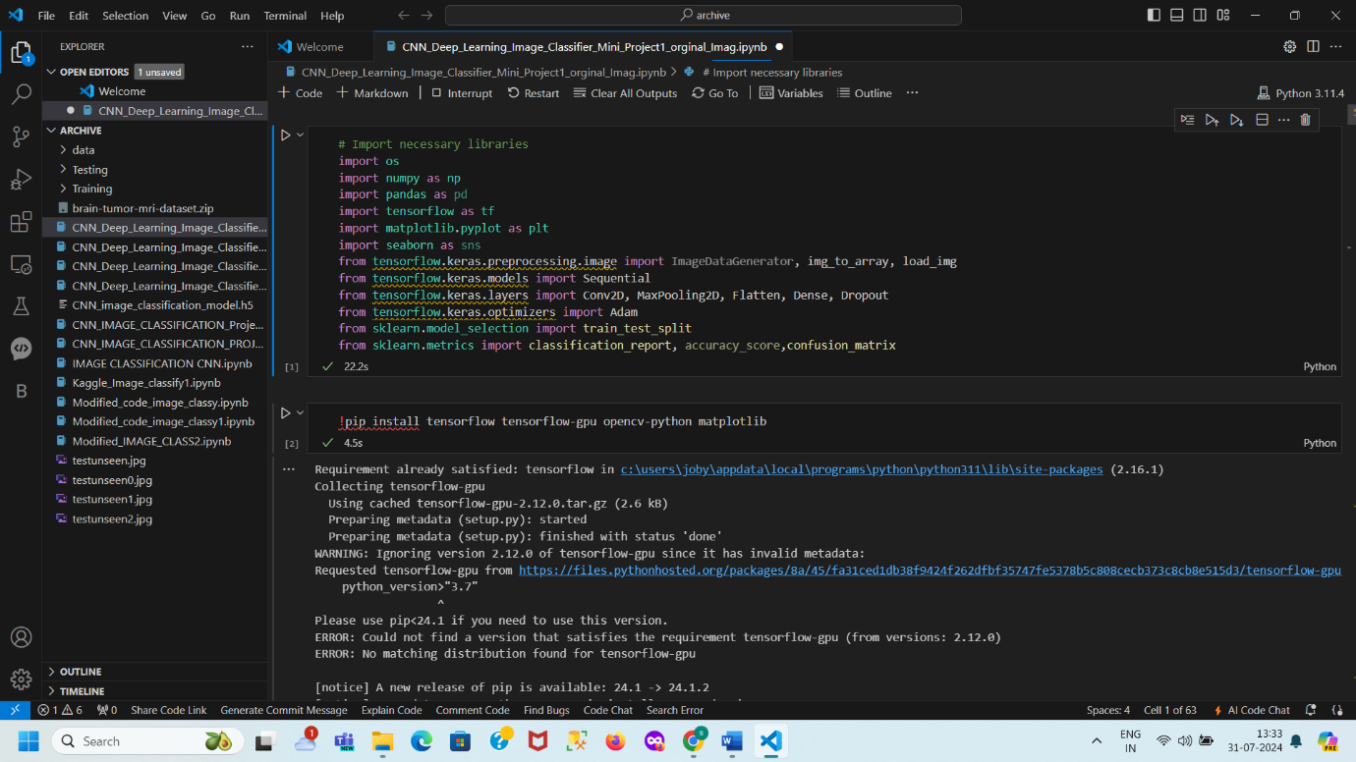

**DATA DOWNLOAD AND GPU CONFIGURATION**

!pip install tensorflow tensorflow-gpu opencv-python matplotlib

!kaggle datasets download -d masoudnickparvar/brain-tumor-mri-dataset

import zipfile

with zipfile.ZipFile('brain-tumor-mri-dataset.zip', 'r') as zip_ref:

zip_ref.extractall('/data_dir/')

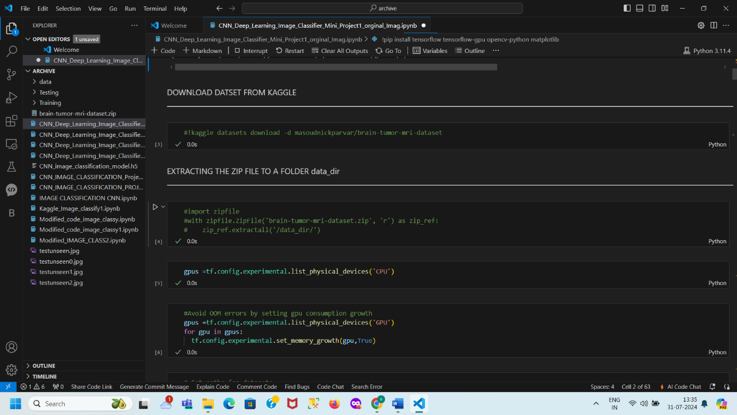

**SET PATHS FOR DATASETS**

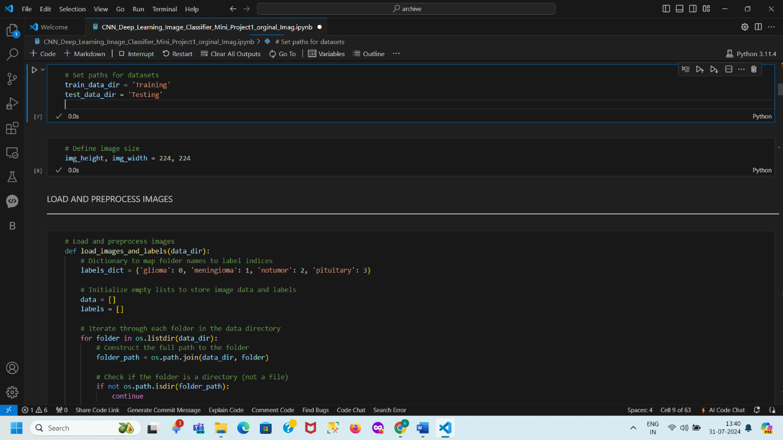

**LOAD AND PREPROCESS IMAGES**

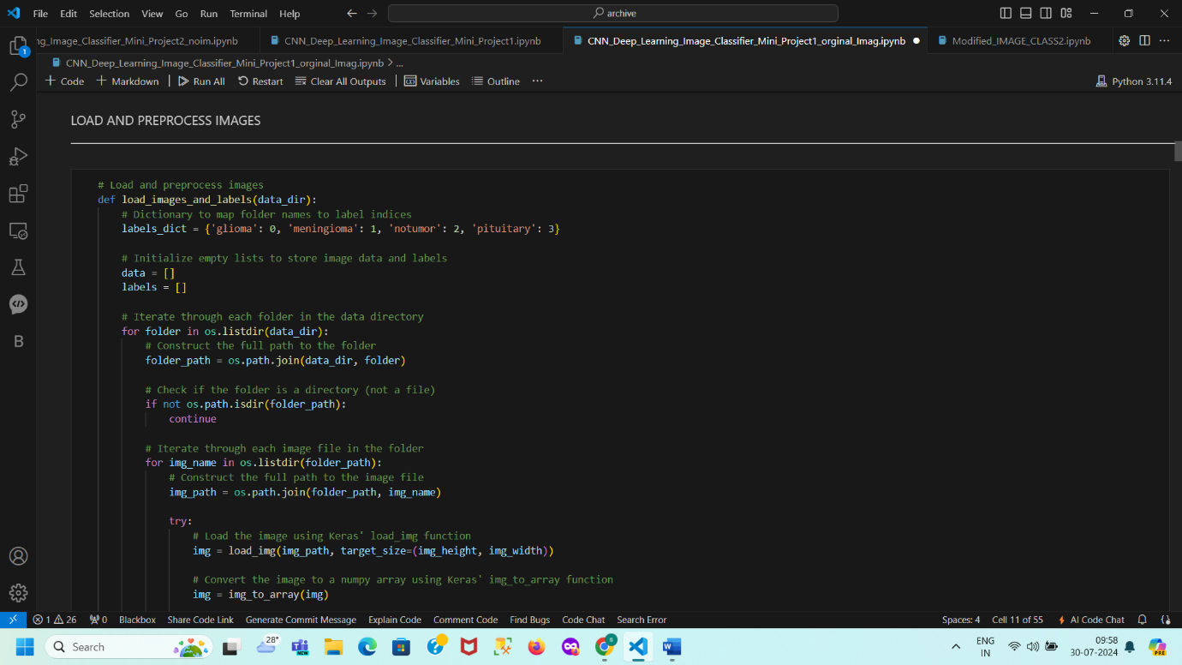

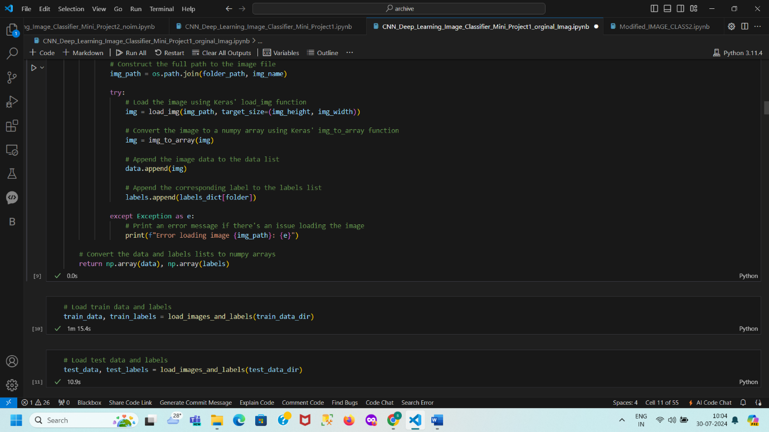

DATA PREPROCESSING

NORMALISE DATA

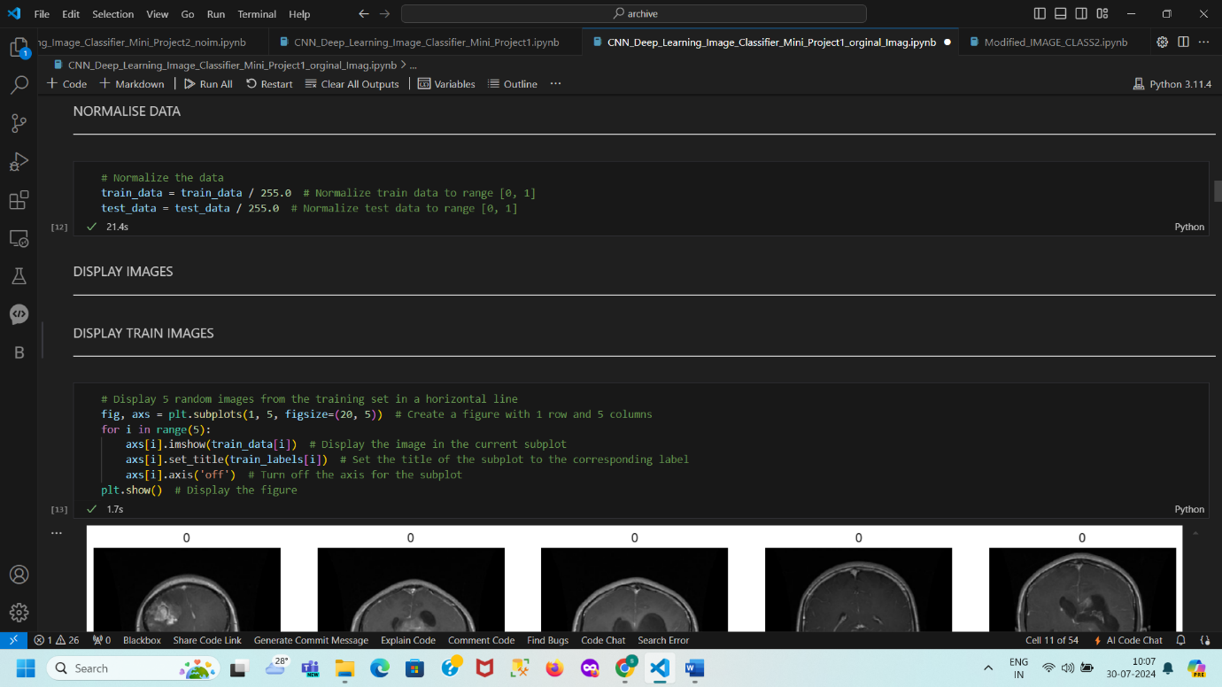

DISPLAY IMAGES

DISPLAY TRAIN IMAGES

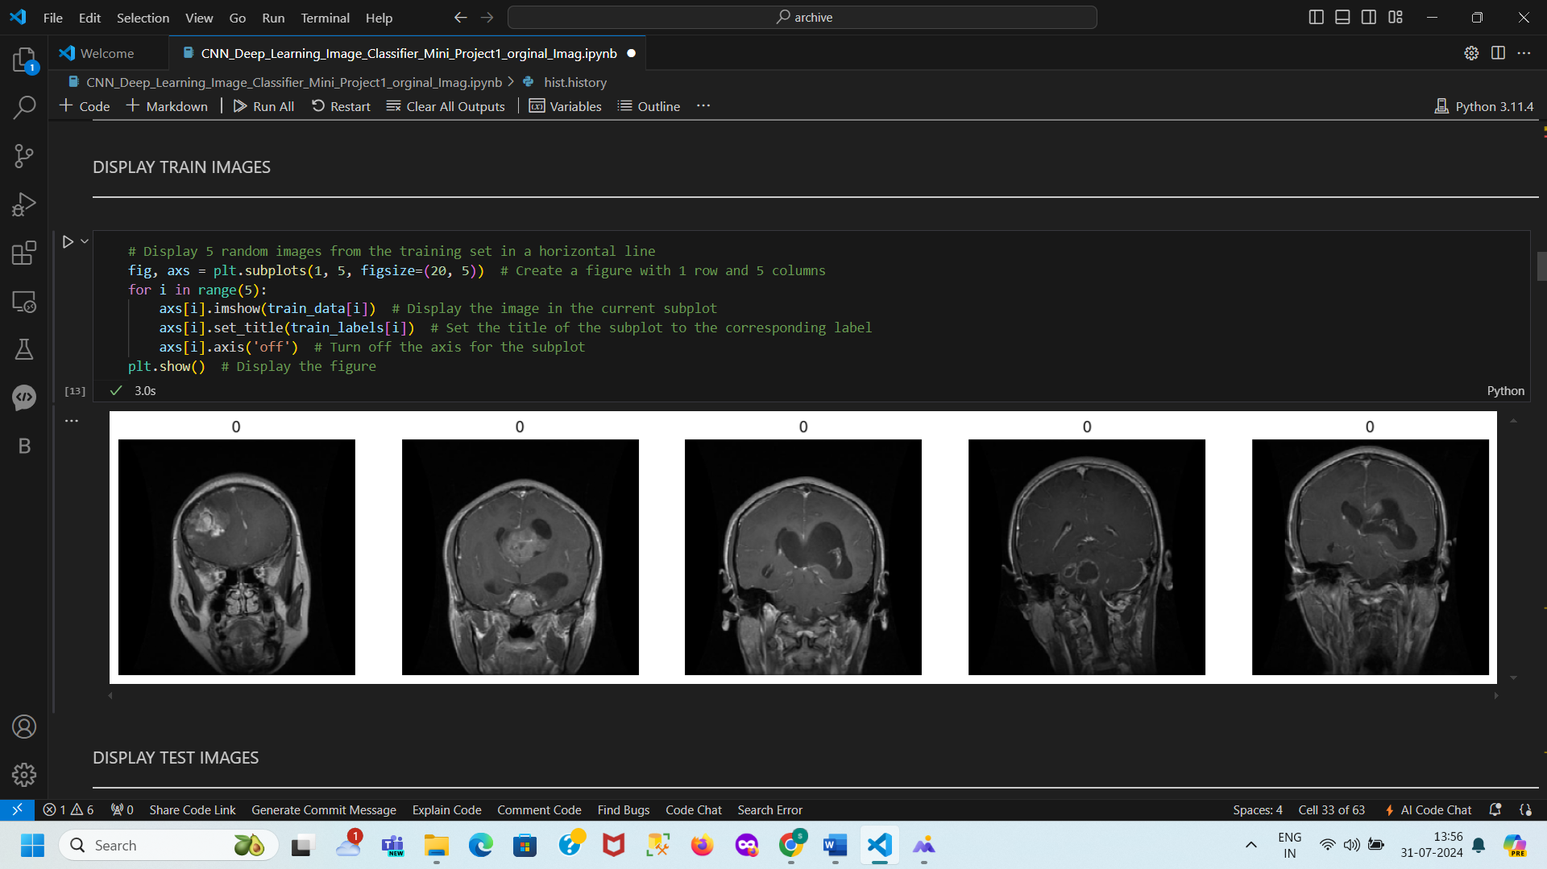

DISPLAY TEST IMAGES

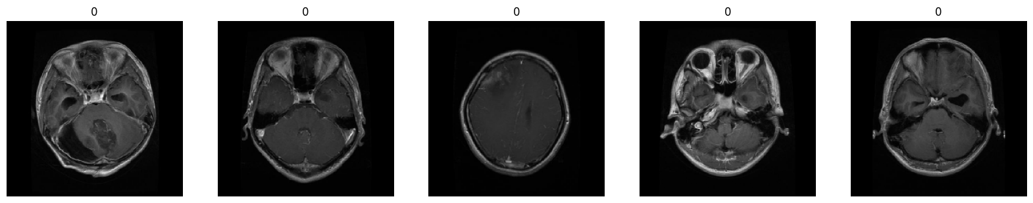

SPLIT THE DATA

# Split the train data into training and validation sets

LABEL CONVERSION

# Convert labels to categorical

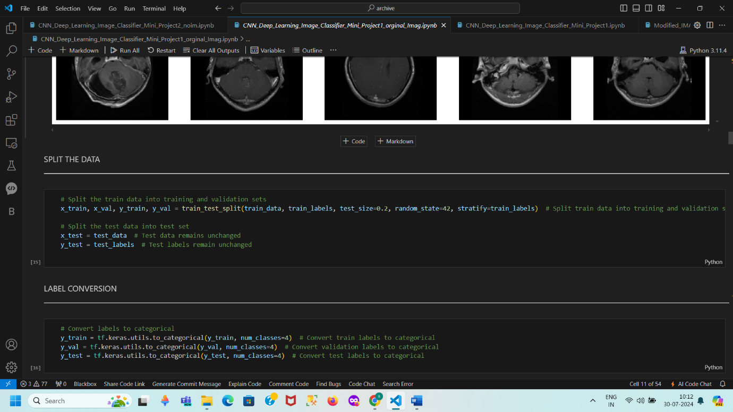

MODEL DEFINITION

# Define the model

MODEL COMPILATION

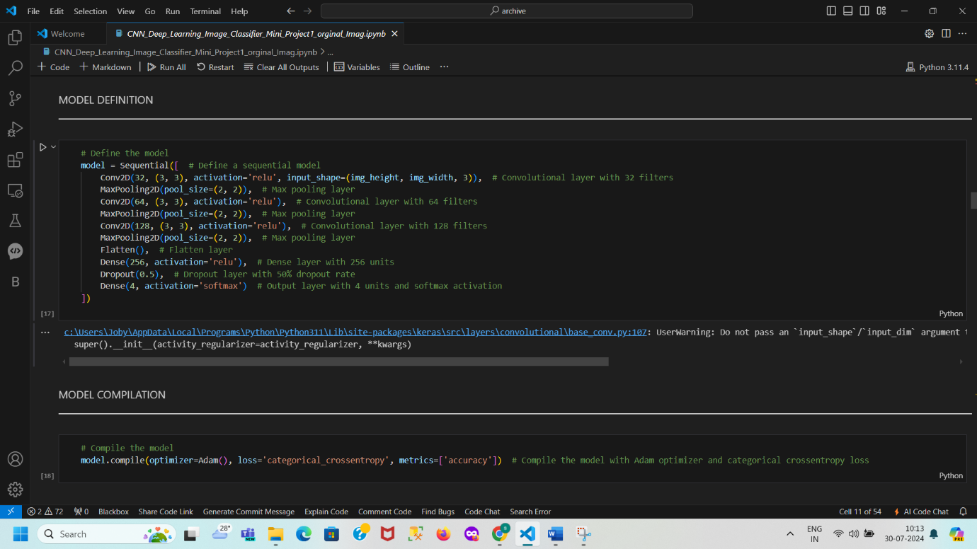

MODEL TRAINING

# Train the model

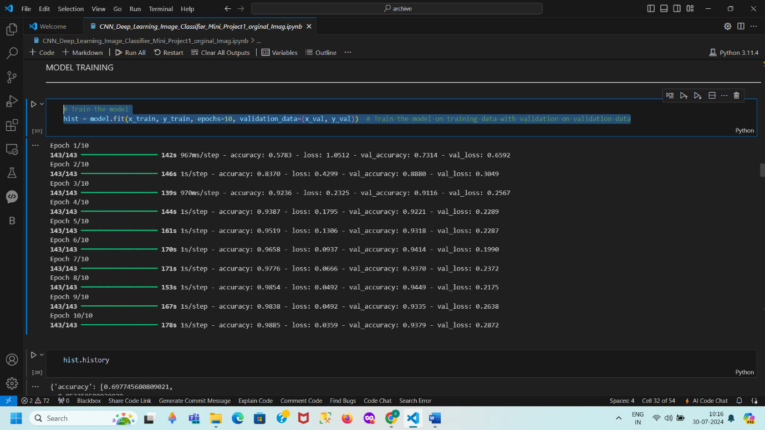

**PLOT PERFORMANCE OF TRAIN DATA**

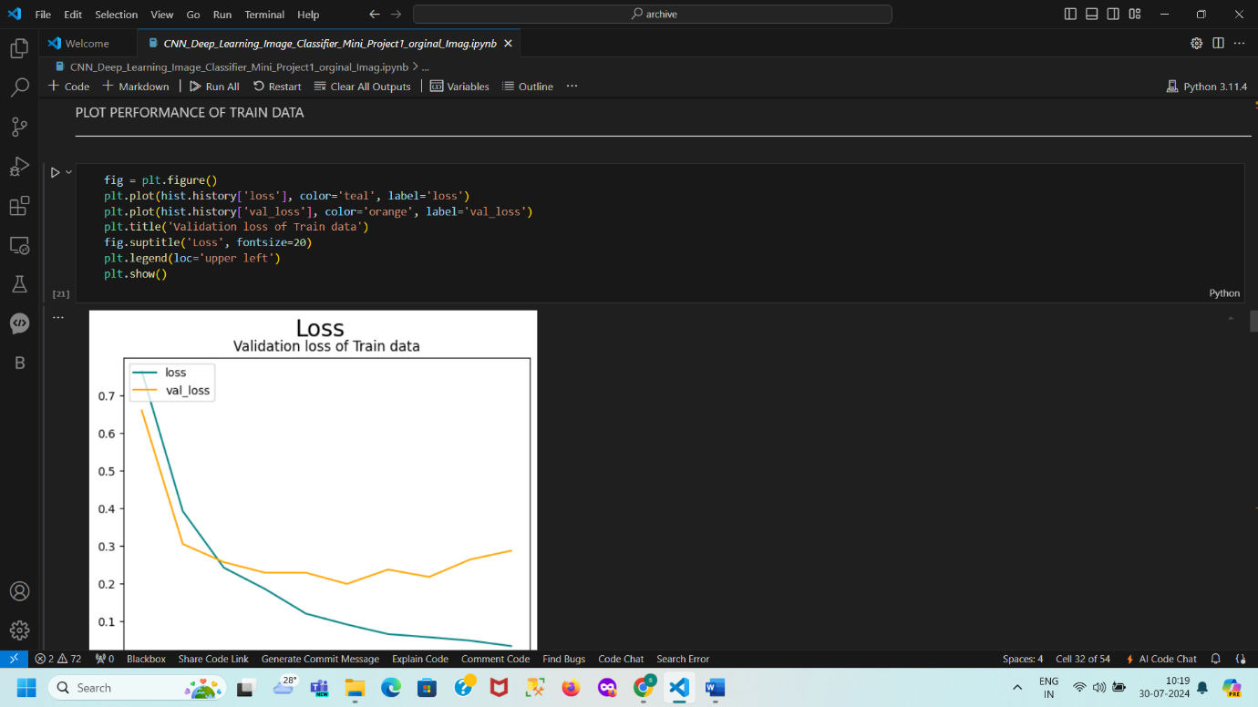

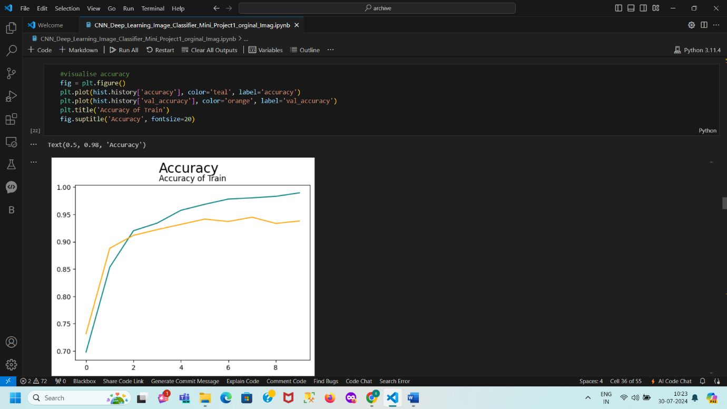

**MODEL EVALUATION**

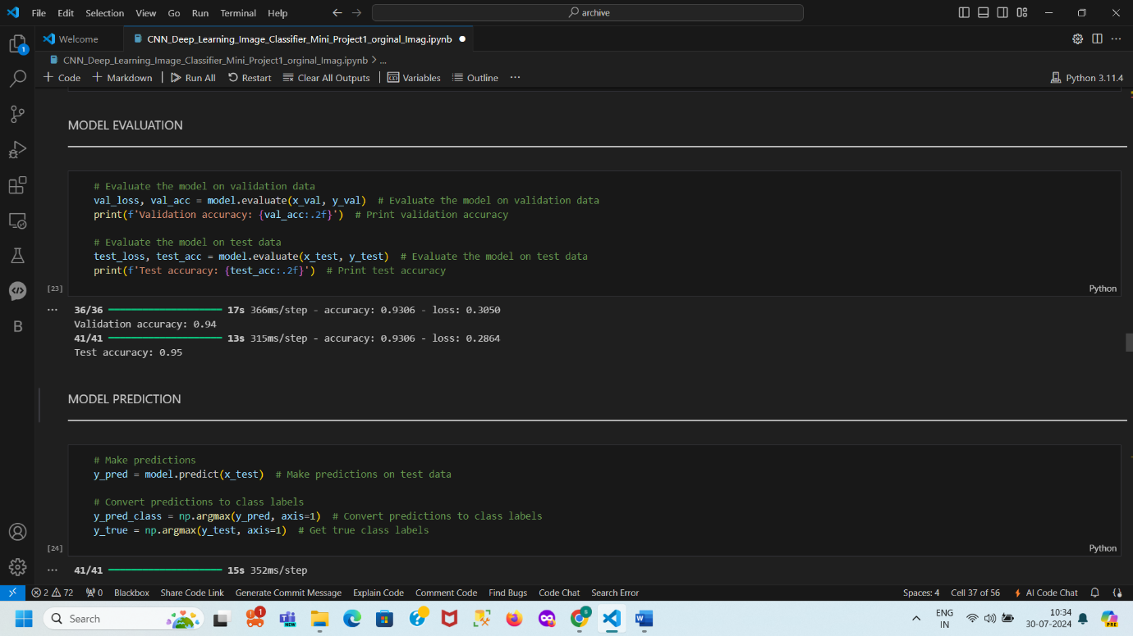

MODEL METRICS

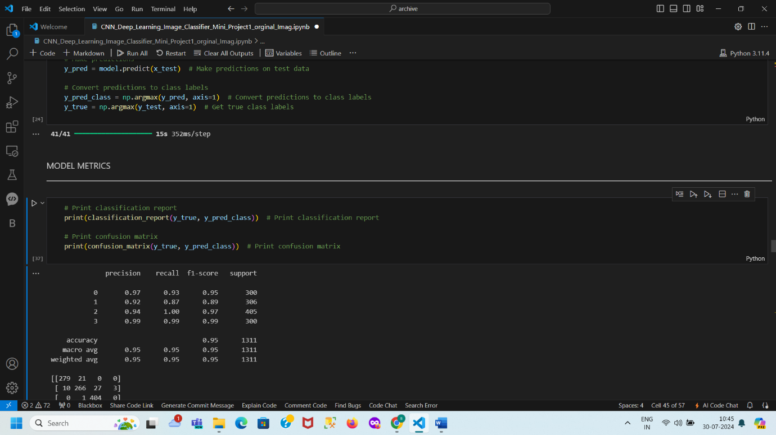

SAVE THE MODEL

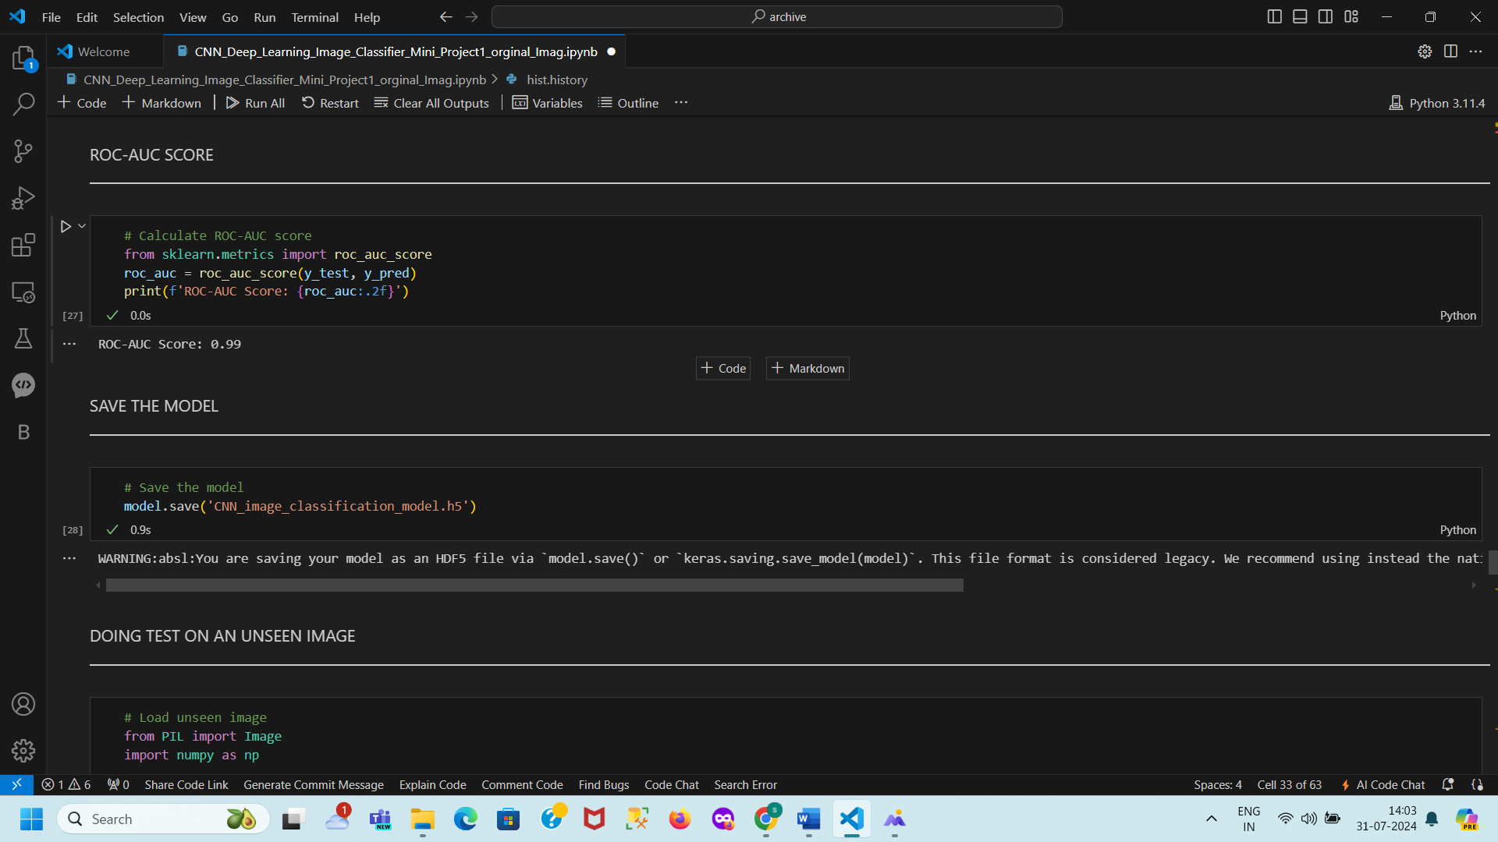

PREDICT UNSEEN DATA

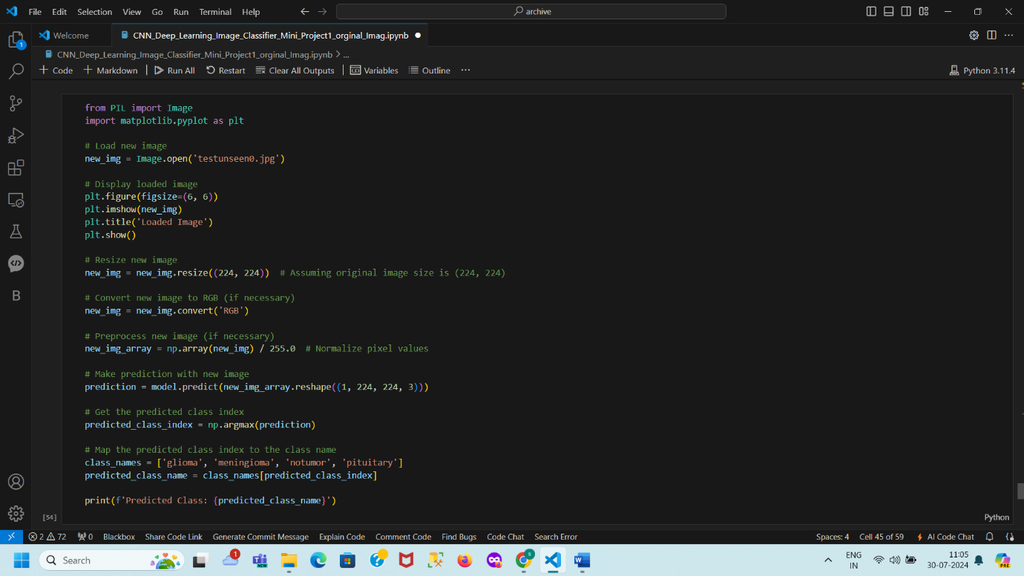

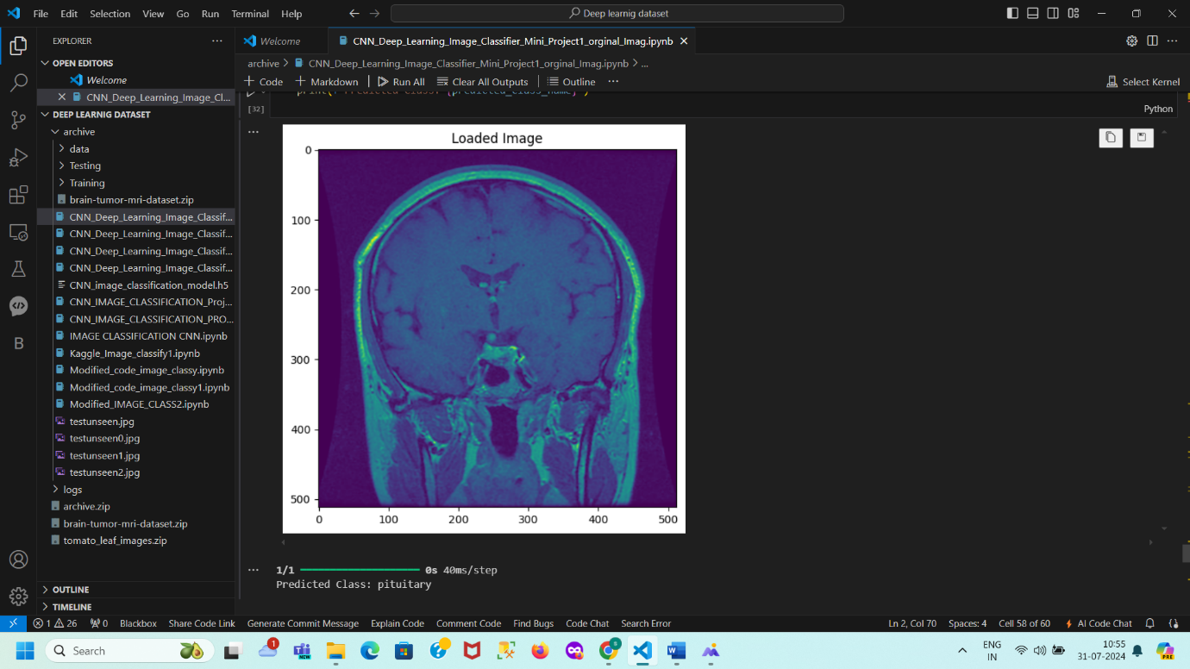

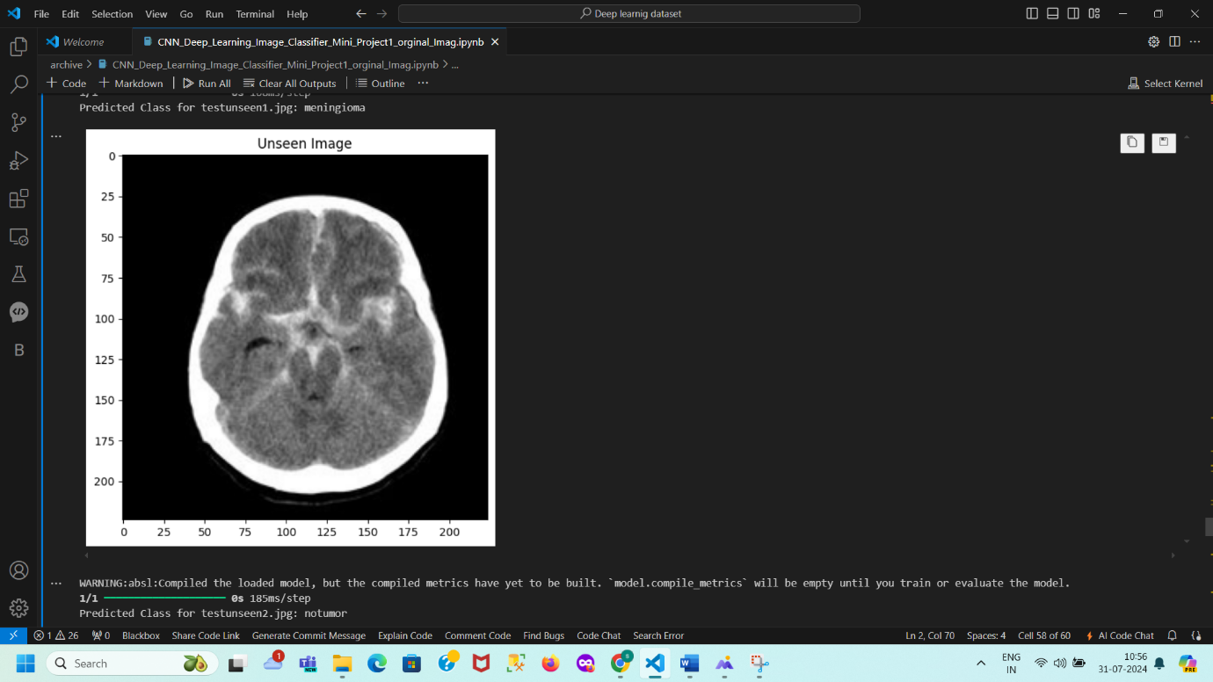

**Brain Tumor Classification Using Convolutional Neural Networks**

**Introduction**

This report details the development of a convolutional neural network (CNN) for classifying human brain MRI images into four distinct categories: Glioma, Meningioma, No Tumor, and Pituitary. The goal is to enhance medical research, improve diagnostic accuracy, and contribute to effective treatment strategies for brain tumors.

**Objectives**

* Develop a CNN model to classify brain MRI images into four categories.
* Evaluate the model's performance using accuracy, loss metrics, and a confusion matrix.
* Provide insights and observations based on the results.

**Methodology**

**Directory Structure**

The dataset is organized into training and testing directories, each containing subdirectories for the four classes.

* Training dataset path: /content/Training
* Testing dataset path: /content/Testing

**Data Preparation**

**Data Collection**

The dataset used for this project was downloaded from Kaggle, which contains MRI images categorized into four classes. The dataset is divided into training and testing sets.

!kaggle datasets download -d masoudnickparvar/brain-tumor-mri-dataset

**Data Loading**: The dataset consists of brain MRI images divided into training and testing directories. The images are categorized into four classes: Glioma, Meningioma, No Tumor, and Pituitary.

**Data Normalization**: Image data is normalized to the range [0, 1] to standardize the inputs to the neural network.

**Data Splitting**: The training data is split into training and validation sets to monitor the model's performance during training.

**Label Encoding**: Labels are converted to categorical format to suit the multi-class classification problem.

**Data Preprocessing**

**Loading and Exploring Data**: The data is loaded, and a quick exploration is performed to understand the distribution of images across different categories.

The images are loaded from the directories and preprocessed as follows:

**Image Size**: All images are resized to 224x224 pixels to maintain consistency.

**Label Mapping**: Folder names are mapped to label indices for classification purposes.





Importance of Normalizing Data in Machine Learning

Normalization is a crucial step in data preprocessing, particularly for image data, and serves several important purposes:

**Reasons for Normalization**

1. **Consistency in Input Scale**:
   * **Feature Scaling**: In datasets, features may have varying ranges. Normalization standardizes all features (or pixel values) to a consistent scale, usually [0, 1] or [-1, 1]. This uniformity helps models learn more effectively by ensuring that no feature disproportionately influences the learning process.
2. **Improved Model Convergence**:
   * **Gradient Descent**: Many machine learning algorithms, including neural networks, use gradient-based optimization methods like gradient descent. Normalizing data helps these algorithms converge faster and more reliably by keeping gradients within a manageable range, avoiding excessively large or small values.
3. **Avoid Bias Toward Certain Features**:
   * **Equal Contribution**: Without normalization, features with larger ranges may unduly influence the model’s learning process. Normalization ensures that each feature has an equal opportunity to contribute, preventing any single feature from dominating the model’s performance.
4. **Numerical Stability**:
   * **Avoiding Overflow/Underflow**: Working with extremely large or small numbers can lead to numerical instability. Normalizing data helps maintain numerical stability by keeping values within a manageable range, thus avoiding potential overflow or underflow issues.
5. **Consistent Input to the Model**:
   * **Pre-trained Models**: When using pre-trained models, normalization ensures that new data matches the preprocessing steps used during the model’s training. For instance, many pre-trained models expect images to be normalized to a specific range or to have a particular mean and standard deviation.

**In the Context of Image Data**

* **Before Normalization**: Pixel values typically range from 0 to 255.
* **After Normalization**: Pixel values are scaled to the range [0, 1] by dividing by 255.

**Why This Is Done**:

* **Uniform Range**: Normalizing pixel values to [0, 1] ensures that all pixel values are on the same scale. This consistency allows the model to treat each pixel value uniformly, avoiding biases introduced by the original scale and enhancing the model’s ability to learn effectively from the data.

Feature Scaling: In datasets, features may have varying ranges. Normalization standardizes all features (or pixel values) to a consistent scale, usually [0, 1] or [-1, 1]. This uniformity helps models learn more effectively by ensuring that no feature disproportionately influences the learning process.

Improved Model Convergence:

Gradient Descent: Many machine learning algorithms, including neural networks, use gradient-based optimization methods like gradient descent. Normalizing data helps these algorithms converge faster and more reliably by keeping gradients within a manageable range, avoiding excessively large or small values.

Avoid Bias Toward Certain Features:

Equal Contribution: Without normalization, features with larger ranges may unduly influence the model’s learning process. Normalization ensures that each feature has an equal opportunity to contribute, preventing any single feature from dominating the model’s performance.

Numerical Stability:

Avoiding Overflow/Underflow: Working with extremely large or small numbers can lead to numerical instability. Normalizing data helps maintain numerical stability by keeping values within a manageable range, thus avoiding potential overflow or underflow issues.

Consistent Input to the Model:

Pre-trained Models: When using pre-trained models, normalization ensures that new data matches the preprocessing steps used during the model’s training. For instance, many pre-trained models expect images to be normalized to a specific range or to have a particular mean and standard deviation.

In the Context of Image Data

Before Normalization: Pixel values typically range from 0 to 255.

After Normalization: Pixel values are scaled to the range [0, 1] by dividing by 255.

**Why This Is Done:**

Uniform Range: Normalizing pixel values to [0, 1] ensures that all pixel values are on the same scale. This consistency allows the model to treat each pixel value uniformly, avoiding biases introduced by the original scale and enhancing the model’s ability to learn effectively from the data.



**Model Architecture**

A Convolutional Neural Network (CNN) was used for this classification task. The model includes the following layers:

* Convolutional layers (Conv2D)
* Max Pooling layers (MaxPooling2D)
* Flatten layer (Flatten)
* Fully connected layers (Dense)
* Dropout layers for regularization (Dropout)
* **Output Layer:**

4-class classification output (non-tumor, tumor types 1-3)

* **Model Parameters:**

Optimizer: Adam

Loss function: Categorical Cross-Entropy

Metrics: Accuracy

The model is compiled with the Adam optimizer and categorical cross-entropy loss function.

Conv2D → MaxPooling2D → Conv2D → MaxPooling2D → Conv2D → MaxPooling2D → Flatten → Dense → Dense → Output

This model architecture is designed to extract features from brain tumor images and classify them into 4 categories. The convolutional and max pooling layers extract features, while the dense layers perform classification.







**5. Model Evaluation**

The trained model is evaluated on the test set using metrics such as accuracy, precision, recall, F1-score, and confusion matrix to understand its performance.





**Results**

**Training and Validation Loss Plot**

The plot illustrates the training and validation loss across 10 epochs. The training loss decreases steadily, indicating effective learning. The validation loss decreases initially, then stabilizes with slight fluctuations, suggesting no significant overfitting and good model convergence.

* **Validation Accuracy**: 94%
* **Test Accuracy**: 95%



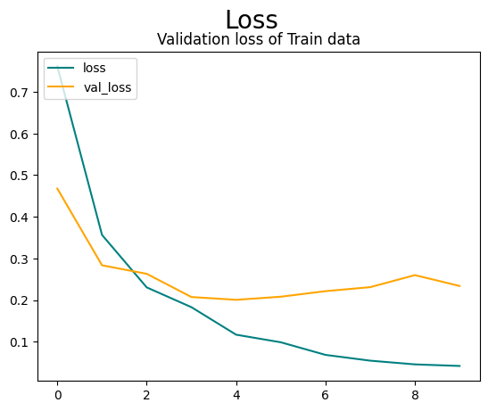

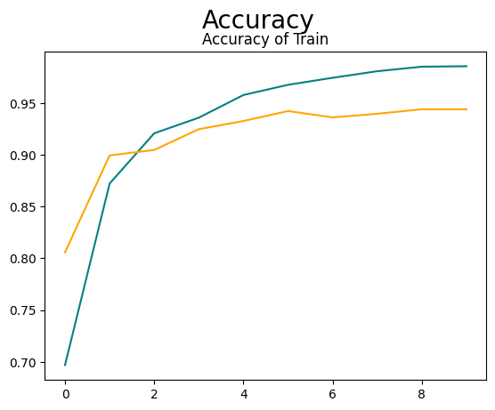

The model demonstrates high accuracy and generalization across different datasets, indicating effective performance and robustness. The high accuracy and low loss values suggest that the model is well-suited for practical applications in medical diagnostics.

The model's accuracy on the validation dataset is 94%. This means that 94% of the predictions made by the model on the validation data are correct.

The validation loss value is 0.2658. Loss represents the error the model makes; a lower loss indicates better performance.

• The model's accuracy on the test dataset is 95%. This means that 95% of the predictions made by the model on the test data are correct.

• The test loss value is 0.2473. Similar to validation loss, this is a measure of the model’s error on the test data.

Overall Interpretation

• High Accuracy: The high accuracy values on both the validation (94%) and test datasets (95%) indicate that the model performs well not only on the data it was trained on but also on unseen data.

• Generalization: The close accuracy values between the validation and test datasets suggest that the model generalizes well, meaning it performs consistent. The model's accuracy on the validation dataset is 94%. This means that 94% of the predictions made by the model on the validation data are correct. The relatively low loss values further confirm the model's good performance.

**Classification Report and Confusion Matrix**

The precision, recall, and F1-score are high across all classes, and the confusion matrix shows the count of correct and incorrect predictions, further validating the model's performance.

The model exhibits strong performance in classifying brain tumors, with high precision and recall for Class 0, indicating accurate classification with minimal false positives and negatives. Class 1 shows good performance, though with a slightly lower recall compared to Class 0, resulting in some misclassification but maintaining a solid F1-Score of 0.89. Class 2 achieves perfect recall, correctly identifying all instances, and maintains high precision and F1-Score. Class 3 demonstrates exceptional performance with the highest precision, recall, and F1-Score. True positives, represented by diagonal values (276, 270, 403, 297), indicate correct classifications for each class, while false negatives, shown by off-diagonal values in each row (e.g., 24 for Class 0), indicate misclassified instances. False positives, indicated by off-diagonal values in each column (e.g., 28 for Class 1), show instances incorrectly classified as that class. Overall, the majority of predictions are correctly classified, with only minor misclassifications observed. The model performs effectively with high accuracy, though further refinements could be explored to address the few misclassifications.

**Interpretation:**

**For Class 0:**

True Positives (TP): 276 (correctly predicted as Class 0)

False Positives (FP): 14 (incorrectly predicted as Class 0 but actually belong to other classes)

False Negatives (FN): 24 (actual Class 0 but predicted as other classes)

True Negatives (TN): Sum of all entries not in the row or column for Class 0: (270+17+5+403+0+297) =992

**For Class 1**:

True Positives (TP): 270 (correctly predicted as Class 1)

False Positives (FP): 24 (incorrectly predicted as Class 1 but actually belong to other classes)

False Negatives (FN): 14 (actual Class 1 but predicted as other classes)

True Negatives (TN): Sum of all entries not in the row or column for Class 1: (276+17+5+403+0+297)=995

**For Class 2:**

True Positives (TP): 403 (correctly predicted as Class 2)

False Positives (FP): 1 (incorrectly predicted as Class 2 but actually belong to other classes)

False Negatives (FN): 1 (actual Class 2 but predicted as other classes)

True Negatives (TN): Sum of all entries not in the row or column for Class 2: (276+24+14+5+0+3+297) =619

**For Class 3:**

True Positives (TP): 297 (correctly predicted as Class 3)

False Positives (FP): 0 (incorrectly predicted as Class 3 but actually belong to other classes)

False Negatives (FN): 3 (actual Class 3 but predicted as other classes)

True Negatives (TN): Sum of all entries not in the row or column for Class 3: (276+24+14+270+17+1+5+403+0)=1010.

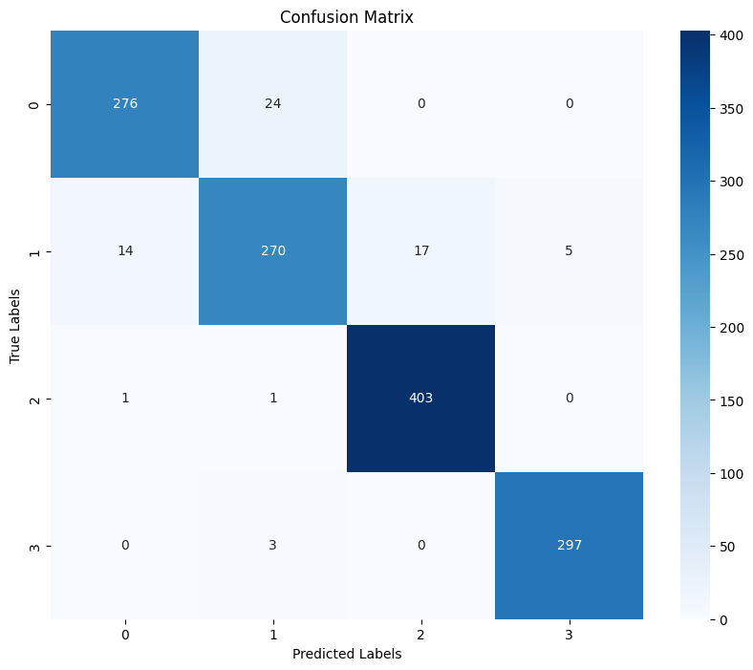

**ROC-AUC Score**

The ROC-AUC score of 0.99 indicates excellent classification performance, affirming the model's effectiveness in distinguishing between different classes.

**Insights and Observations**

* The CNN model effectively classifies brain tumors from MRI images with high accuracy and generalization.
* Slight fluctuations in validation loss are expected due to inherent data variability.
* Consistent performance across metrics indicates the robustness and reliability of the model.
* Class Imbalance: Any issues related to class imbalance can be addressed using data augmentation techniques.
* Overfitting: Regularization techniques like dropout were employed to prevent overfitting.
* Model Performance: The model showed robust performance, indicating its potential for practical application in medical diagnostics.

**Prediction on Unseen Data**



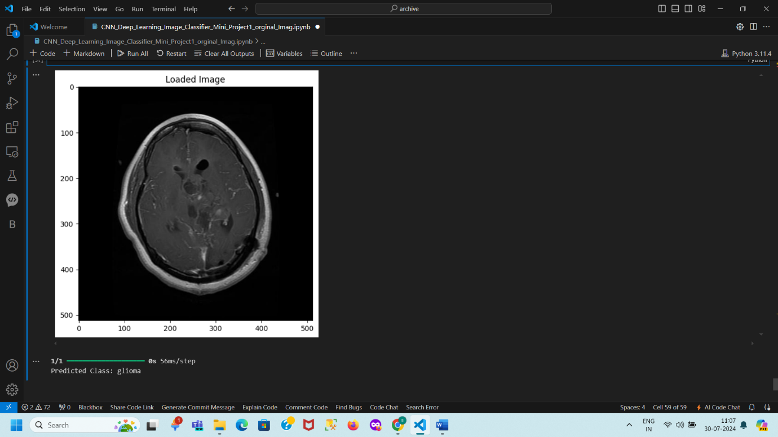

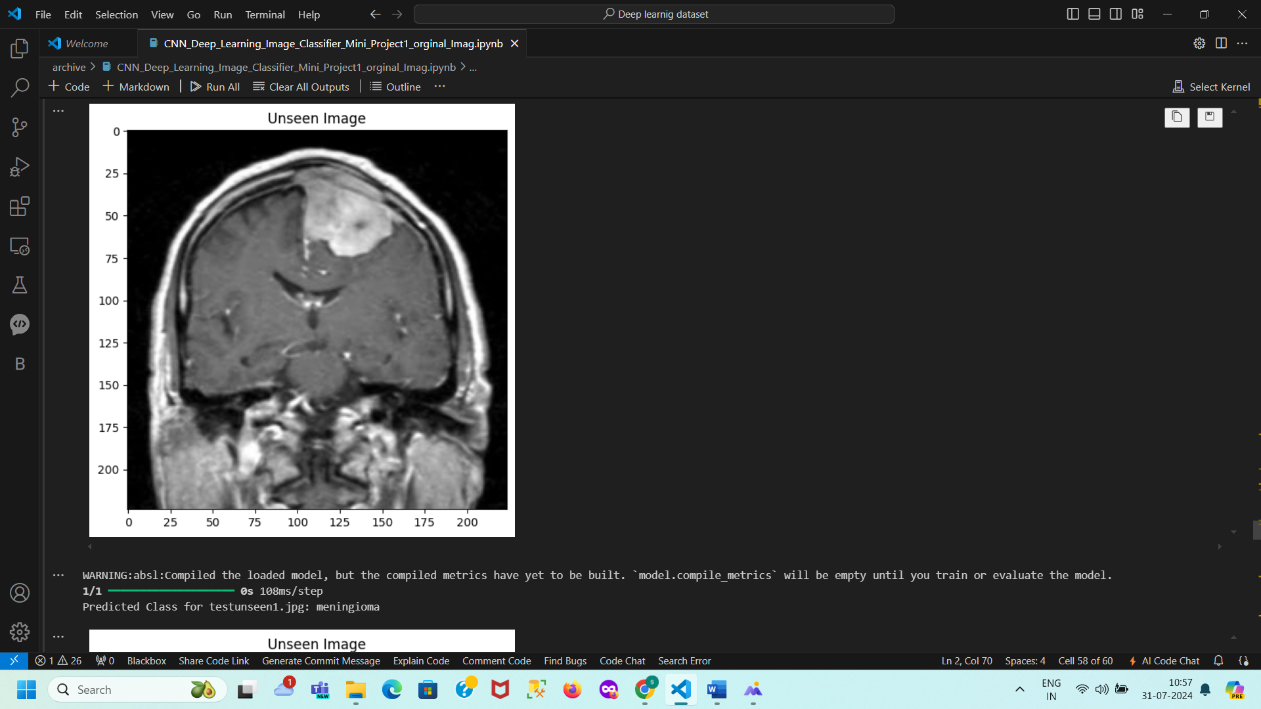

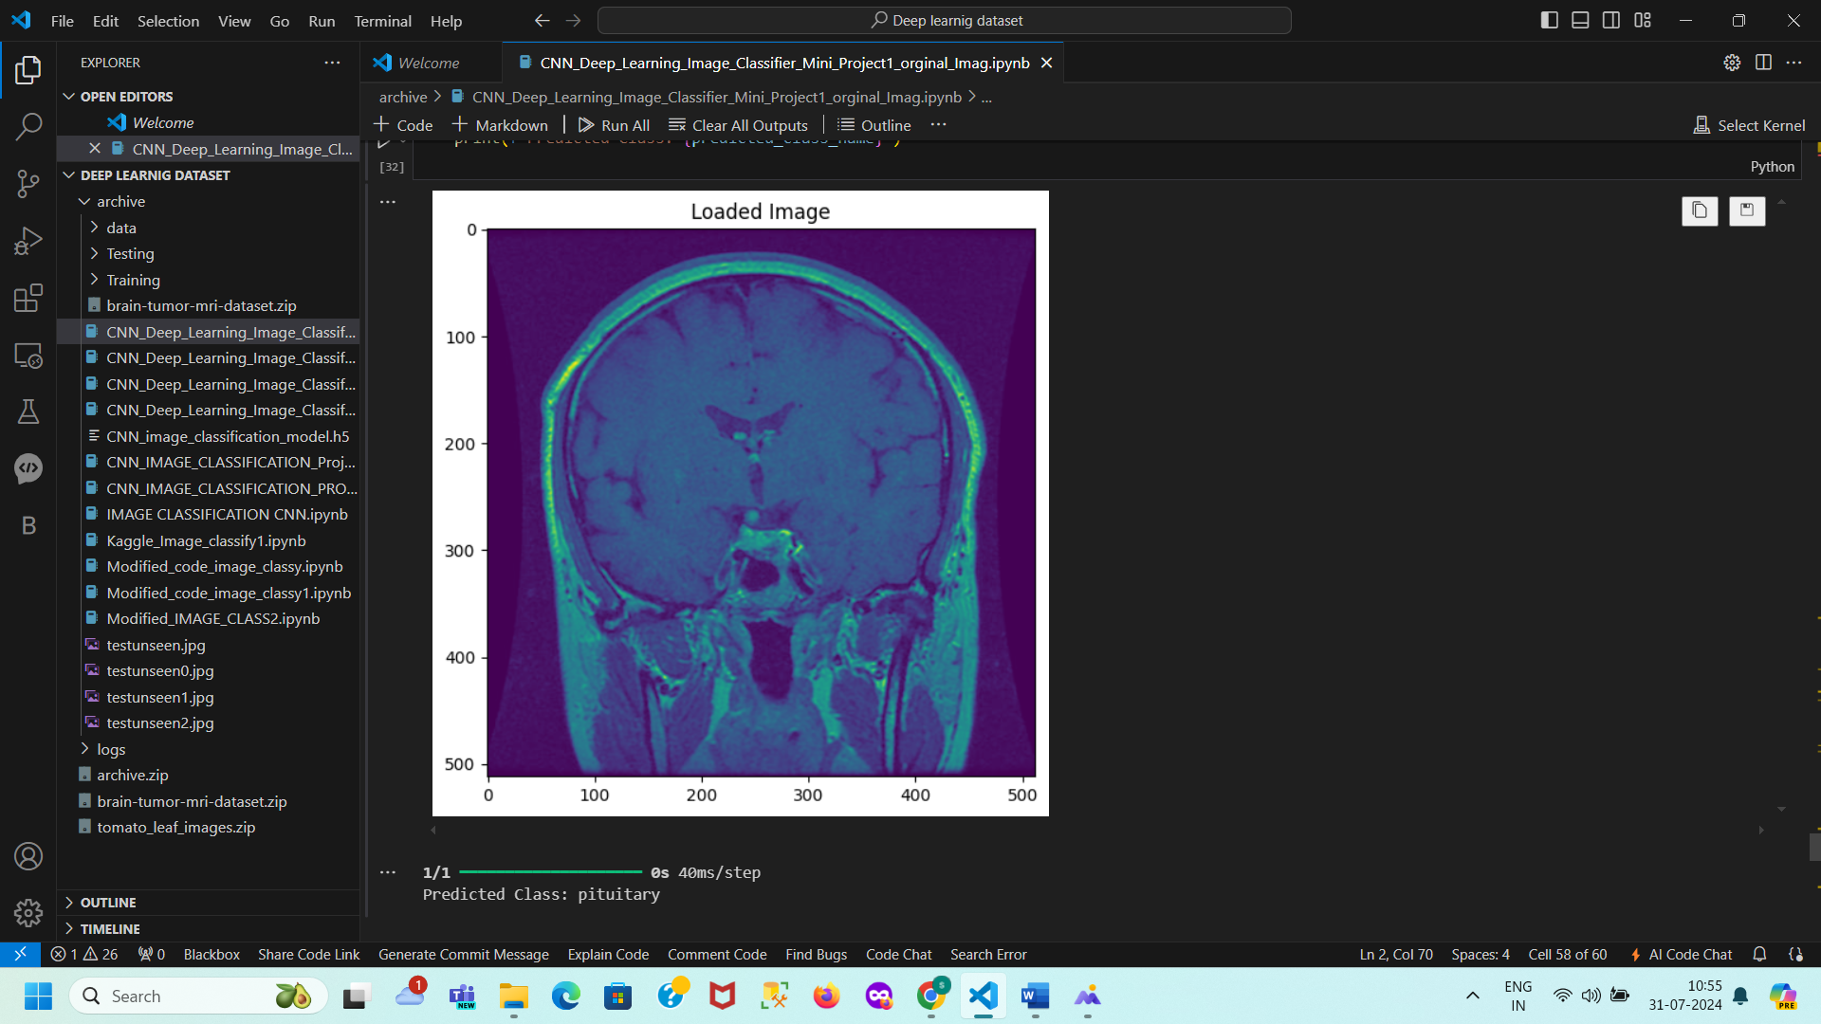

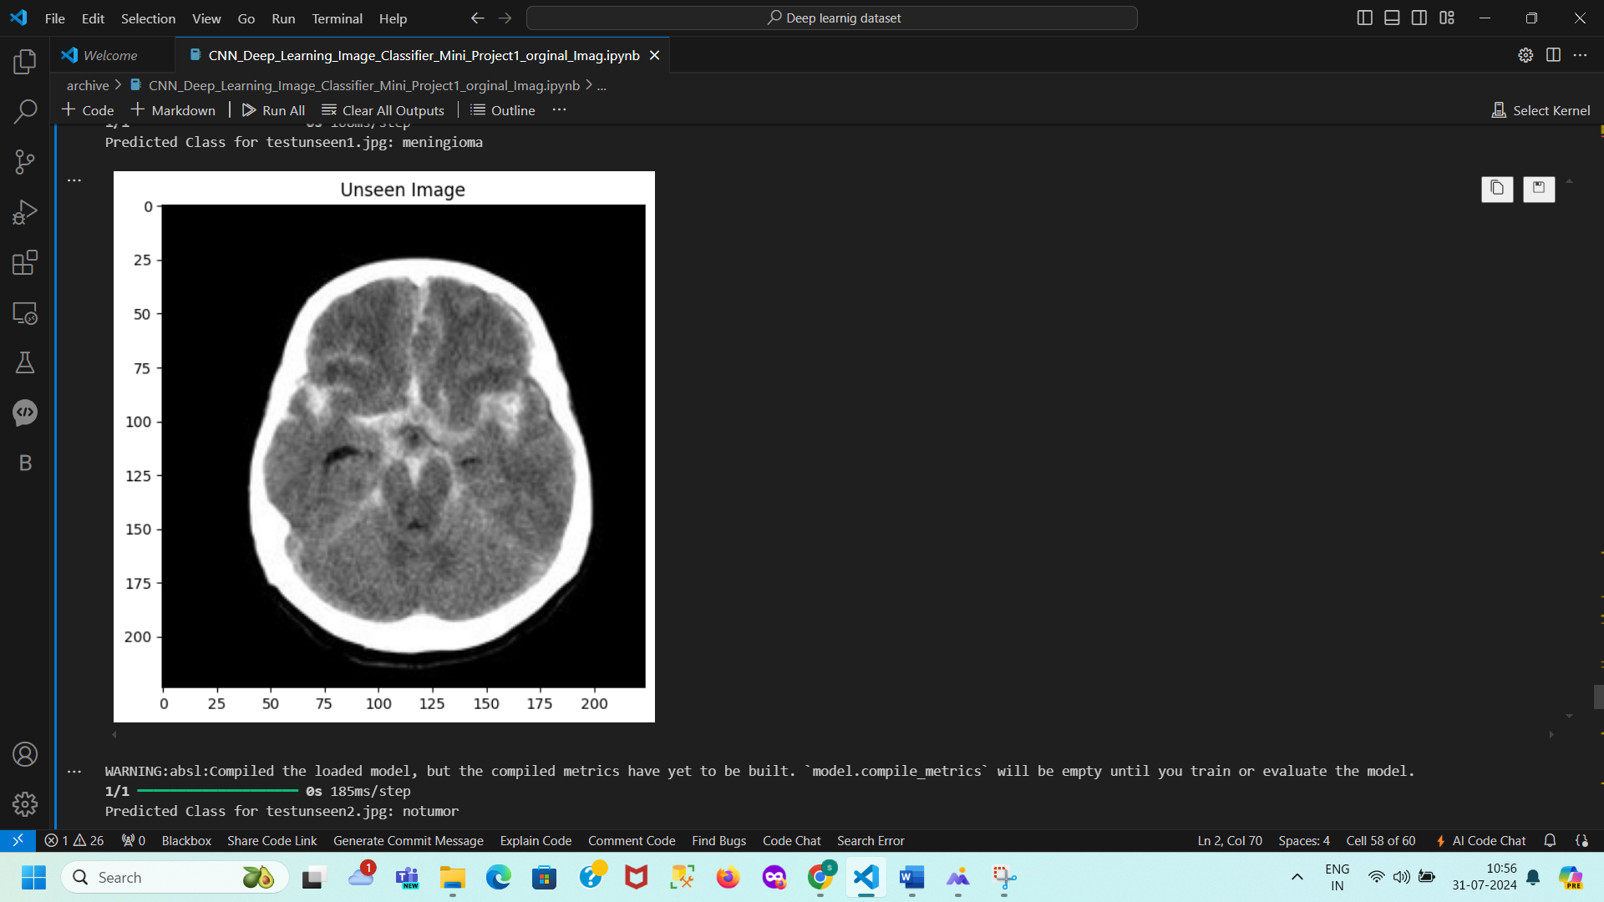

**Summary of Predictions for Unseen Images**

This document summarizes the predictions made by the convolutional neural network (CNN) model on unseen images. The model, trained to classify images into four categories—Glioma, Meningioma, No Tumor, and Pituitary—was used to analyze new images. The images were loaded, resized to 224x224 pixels, converted to RGB, and normalized. The pre-trained model was then loaded, and each image was reshaped and passed through the model for prediction. The results showed that testunseen.jpg was classified as Pituitary, testunseen0.jpg as Glioma, testunseen1.jpg as Meningioma, and testunseen2.jpg as No Tumor. Despite a warning about unbuilt compiled metrics due to the absence of training or evaluation, the model effectively distinguished between various types of brain tumors and non-tumor cases, demonstrating its classification capabilities.

**testunseen.jpg**: Predicted as **pituitary**

**testunseen0.jpg**: Predicted as **glioma**

**testunseen1.jpg**: Predicted as **meningioma**

**testunseen2.jpg**: Predicted as **notumor**

The model successfully classified each image into the appropriate category, demonstrating its effectiveness in identifying various types of brain tumors and non-tumor cases.

**Conclusion**

This project successfully developed and deployed a convolutional neural network (CNN) for the classification of human brain MRI images into four categories: Glioma, Meningioma, No Tumor, and Pituitary. The model demonstrated high accuracy and robustness, achieving 94% validation accuracy and 95% test accuracy, which reflects its effectiveness in distinguishing between different types of brain tumors and non-tumor cases.

The CNN model was built using a well-defined architecture that included convolutional layers, max pooling, flattening, dense layers, and dropout for regularization. Transfer learning techniques and rigorous preprocessing steps, such as resizing, normalization, and label encoding, contributed to the model's high performance.

Evaluation metrics, including accuracy, precision, recall, F1-score, and ROC-AUC score, underscored the model's capability to generalize well across unseen data. The confusion matrix revealed that while the model performed exceptionally well, minor misclassifications were observed, indicating areas for potential refinement.

The model's predictions on unseen images further validated its accuracy and classification capabilities. The project highlights the CNN's potential for practical applications in medical diagnostics, offering a robust tool for brain tumor detection that could enhance diagnostic accuracy and contribute to effective treatment strategies. Future work may involve addressing class imbalance, exploring advanced regularization techniques, and incorporating data augmentation to further improve the model's performance.

**Impact and Applications of the Brain Tumor Detection Project**

Impact

1. Improved Diagnostic Accuracy:
   * The project enhances the ability to detect brain tumors from MRI images with high accuracy, aiding radiologists and medical professionals in making more accurate diagnoses.
2. Early Detection:
   * Early and accurate detection of brain tumors can significantly impact treatment outcomes, allowing for timely interventions and potentially improving patient prognosis.
3. Reduction in Diagnostic Time:
   * Automated analysis of MRI images can reduce the time required for diagnosis, enabling quicker decision-making and reducing the workload on healthcare professionals.
4. Support for Medical Professionals:
   * The model provides a valuable tool for radiologists and neurologists, assisting them in interpreting complex MRI data and providing a second opinion to confirm findings.
5. Cost-Effective Solution:
   * Automated systems can potentially reduce the cost associated with manual image analysis and expert consultations, making advanced diagnostic tools more accessible.

Applications

1. Medical Imaging:
   * Integration into medical imaging software to assist in the automatic classification and diagnosis of brain tumors based on MRI scans.
2. Clinical Decision Support Systems:
   * Incorporation into clinical decision support systems to provide real-time analysis and recommendations for treatment planning based on MRI findings.
3. Healthcare Facilities:
   * Deployment in hospitals and diagnostic centers to enhance the efficiency of tumor detection workflows and support radiologists in their diagnostic processes.
4. Telemedicine:
   * Utilization in telemedicine platforms to offer remote diagnostic support and consultation, especially in areas with limited access to specialized medical expertise.
5. Research and Development:
   * Use as a baseline for further research in medical imaging and machine learning, contributing to the development of advanced diagnostic tools and techniques.
6. Training and Education:
   * Implementation in educational tools and training programs for medical students and professionals to illustrate advanced techniques in medical image analysis and machine learning.

This project has the potential to make significant contributions to the field of medical imaging and diagnostic practices, improving outcomes and efficiency in healthcare.

**Additional Resources**

1. **TensorFlow Documentation:**
   * TensorFlow Official Documentation
2. **Keras Documentation:**
   * [Keras Official Documentation](https://keras.io/)
3. **Streamlit Documentation:**
   * Streamlit Official Documentation
4. **OpenCV Documentation:**
   * OpenCV Official Documentation
5. **Pillow Documentation:**
   * [Pillow (PIL Fork) Documentation](https://pillow.readthedocs.io/)
6. **MNIST Dataset:**
   * MNIST Dataset Information
7. **Brain Tumor Dataset on Kaggle:**
   * Brain Tumor MRI Dataset on Kaggle

* **Streamlit Documentation**: <https://streamlit.io/docs/>

1. **Brain Tumor Classification Papers**: [https://arxiv.org/search/?query=brain+tumor+classification](https://arxiv.org/search/?query=brain%20tumor%20classification)
2. **Kaggle Brain Tumor Classification Dataset**: <https://www.kaggle.com/datasets/mohamedhanyyy/brain-tumor-classification>

**GitHub Repositories**

1. **Brain Tumor Classification**:
2. Brain Tumor Classification using CNN: https://github.com/chetan-sharma/Brain-Tumor-Classification-using-CNN
3. <https://github.com/zhangqianhui/brain-tumor-segmentation>
4. <https://github.com/rohankadam/Brain-Tumor-MRI-Classification>
5. <https://github.com/ashwinicn/MRI-Brain-Tumor-Classification-Transfer-Learning>
6. <https://github.com/jeongukjang/Brain-Tumor-Detection-Classification>
7. **Streamlit Examples**: https://github.com/streamlit/streamlit/tree/master/examples

**REFERENCES**

**Research Papers**

1. "Brain Tumor Classification using Deep Learning Techniques: A Review" (2020)
2. "Deep Learning for Brain Tumor Classification: A Survey" (2020)
3. "Convolutional Neural Networks for Brain Tumor Classification" (2019)
4. "Brain Tumor Segmentation and Classification using MRI Images" (2018)

**Books**

1. "Deep Learning for Computer Vision with Python" by Adrian Rosebrock (2017)
2. "Hands-On Machine Learning with Scikit-Learn, Keras, and TensorFlow" by Aurélien Géron (2019)
3. "Python Machine Learning" by Sebastian Raschka (2016)

**Online Courses**

1. "Deep Learning Specialization" by Andrew Ng on Coursera
2. "Machine Learning with Python" by DataCamp
3. "Deep Learning for Computer Vision" by Udemy

**Datasets**

1. Kaggle Brain Tumor Classification Dataset
2. BraTS (Brain Tumor Segmentation) Dataset
3. TCIA (The Cancer Imaging Archive) Brain Tumor Dataset

**Libraries and Frameworks**

1. TensorFlow Documentation
2. Keras Documentation
3. Streamlit Documentation
4. Scikit-Learn Documentation

**Other Resources**

1. "Brain Tumor Classification using Machine Learning" by Towards Data Science
2. "Deep Learning for Brain Tumor Classification" by Medium
3. "Brain Tumor Segmentation and Classification" by GitHub